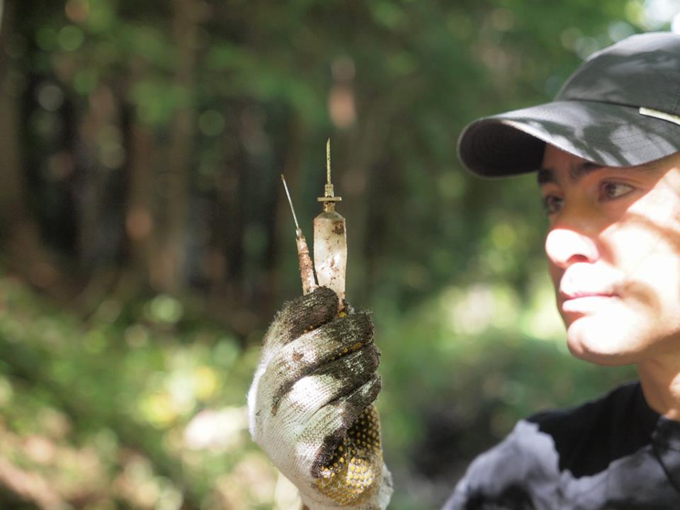

[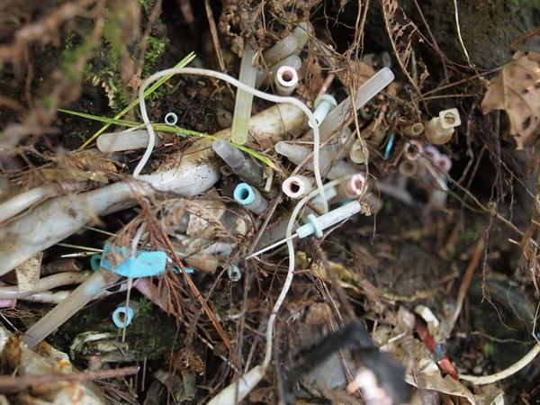](http://www.noguchi-ken.com/M/images/20121015_5.jpg)

[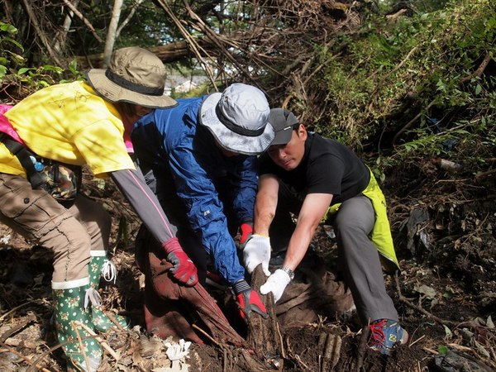](http://www.noguchi-ken.com/M/images/20121015_3.jpg)

[](http://www.noguchi-ken.com/M/images/20121015_4.jpg)

[](http://www.noguchi-ken.com/M/images/20121015_6.jpg)

[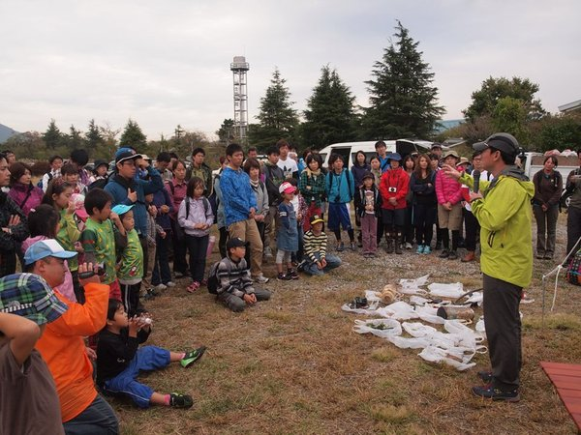](http://www.noguchi-ken.com/M/images/20121015_11.jpg)

[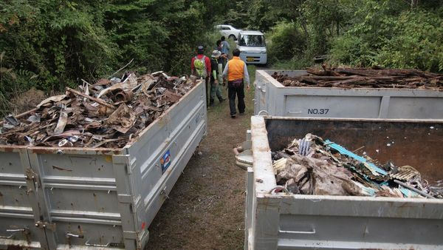](http://www.noguchi-ken.com/M/images/2012.09.28%E5%AF%8C%E5%A3%AB%E5%B1%B1%EF%BC%93.jpg)

