[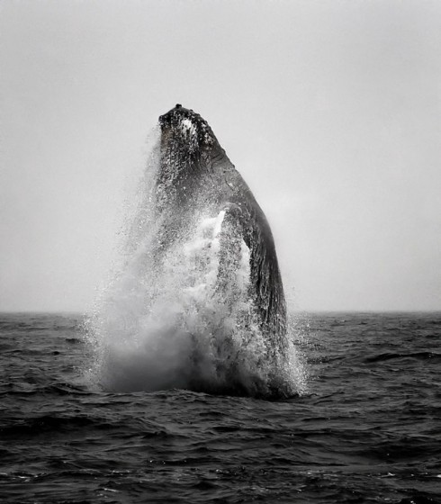](http://www.inspiration-gallery.net/wp-content/uploads/20110127_an01_030.jpg)

[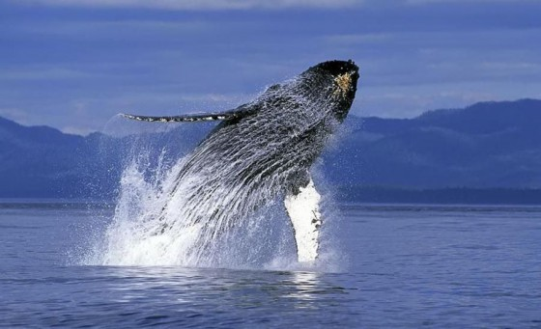](http://www.inspiration-gallery.net/wp-content/uploads/20110127_an01_029.jpg)

[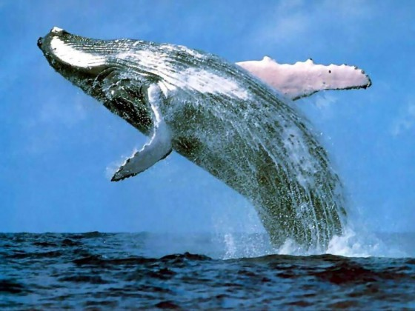](http://www.inspiration-gallery.net/wp-content/uploads/20110127_an01_015.jpg)

[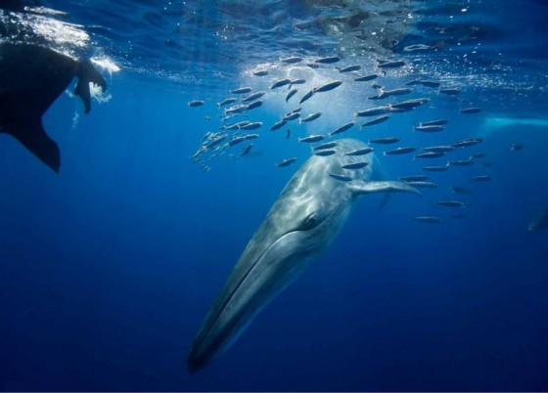](http://www.inspiration-gallery.net/wp-content/uploads/20110127_an01_035.jpg)

[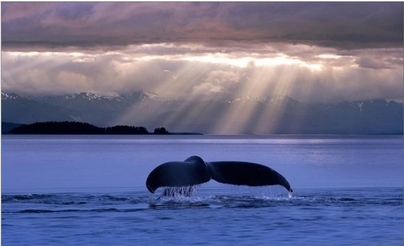](http://www.inspiration-gallery.net/wp-content/uploads/20110127_an01_037.jpg)

[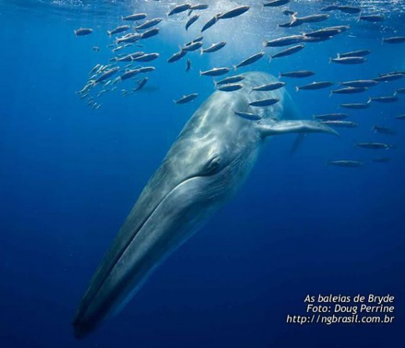](http://www.inspiration-gallery.net/wp-content/uploads/20110127_an01_014.jpg)

[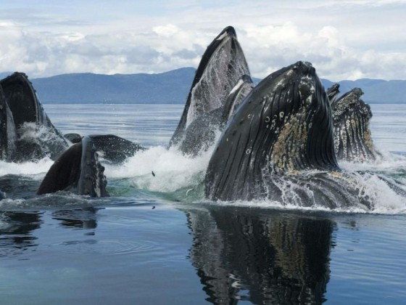](http://www.inspiration-gallery.net/wp-content/uploads/20110127_an01_016.jpg)

[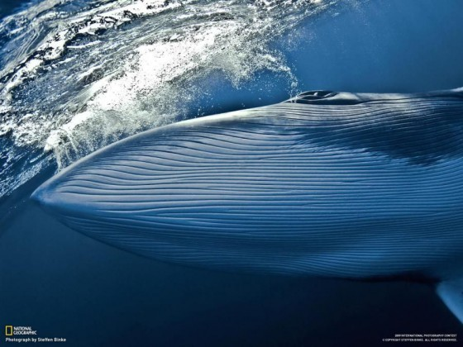](http://www.inspiration-gallery.net/wp-content/uploads/20110127_an01_001.jpg)